**Phase 8: Data Management & Deployment**

**Data Import Wizard:**

**What it is**: A Salesforce tool for importing small amounts of data (up to 50,000 records) using a simple UI.  
 **Used for**: Importing Accounts, Contacts, Leads, Solutions, and custom object records. Supports CSV files

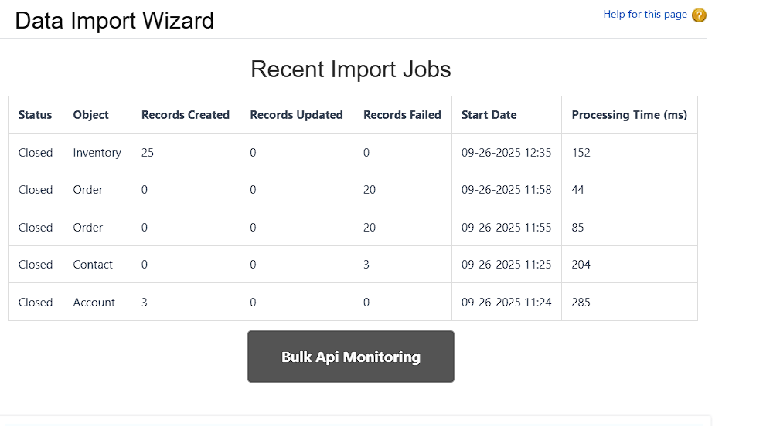

**Data Loader:**

**What it is:** A client application (desktop or CLI) to insert, update, upsert, delete, or export large volumes of data (up to 5 million records).  
 **Used for:** Handling bulk data operations not supported by Import Wizard.

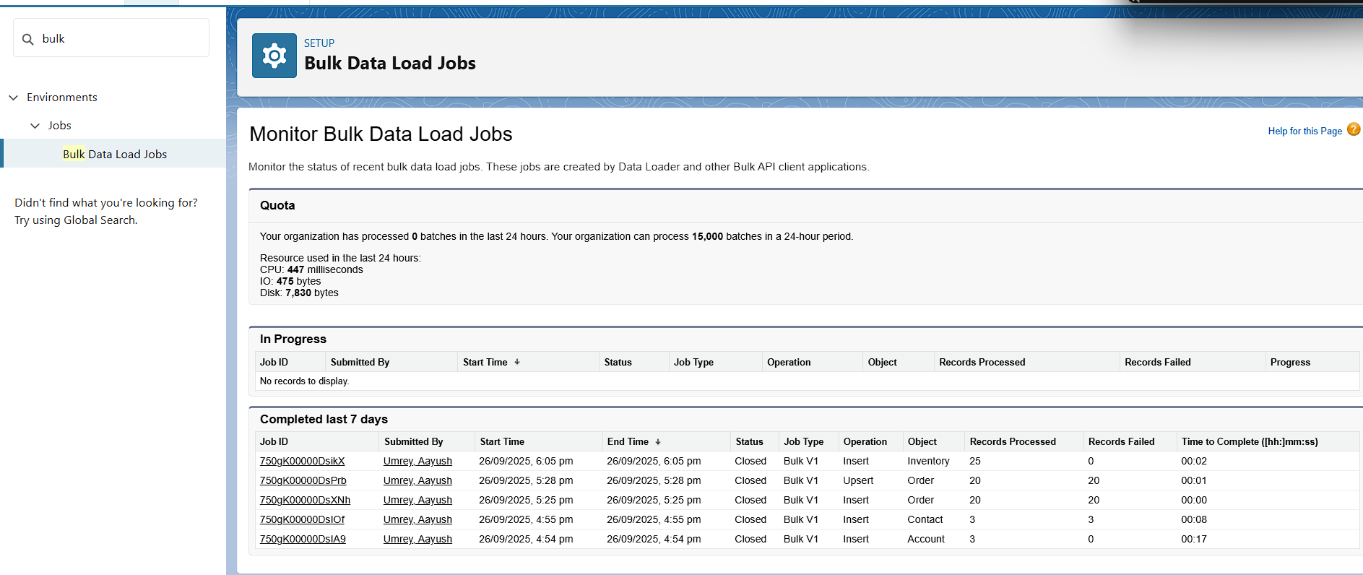

**Duplicate Rules:**

**What it is:** Rules in Salesforce that prevent or alert users when duplicate records are created.  
 **Used for:** Maintaining clean data by matching on fields like email, phone, or custom criteria.

**Created:** Matching rule Order_Number__c and Duplicate rule Order_Duplicate_Rule

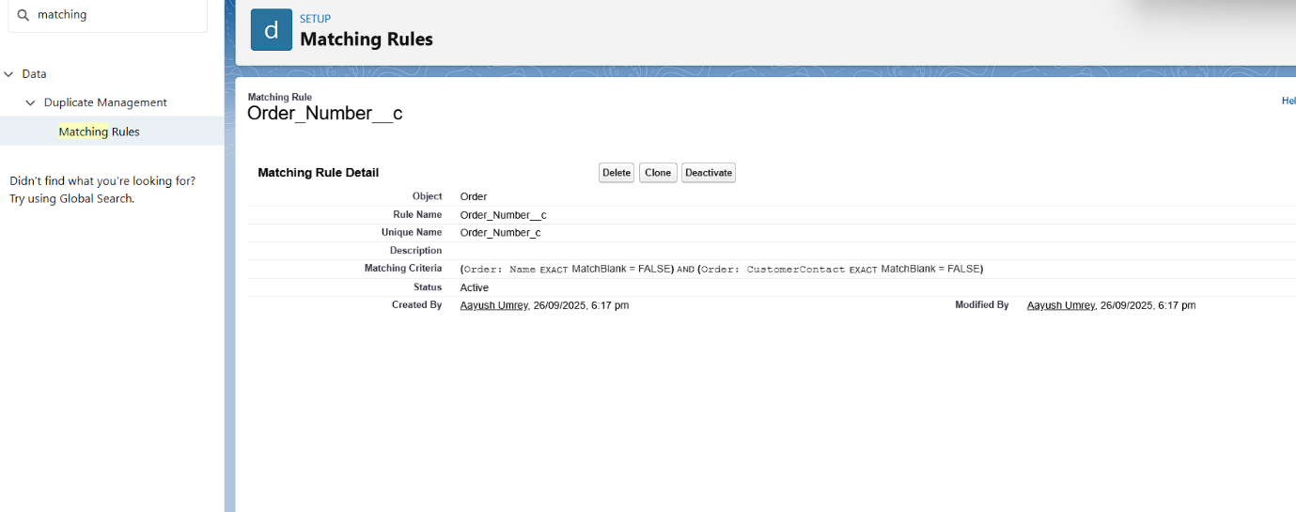

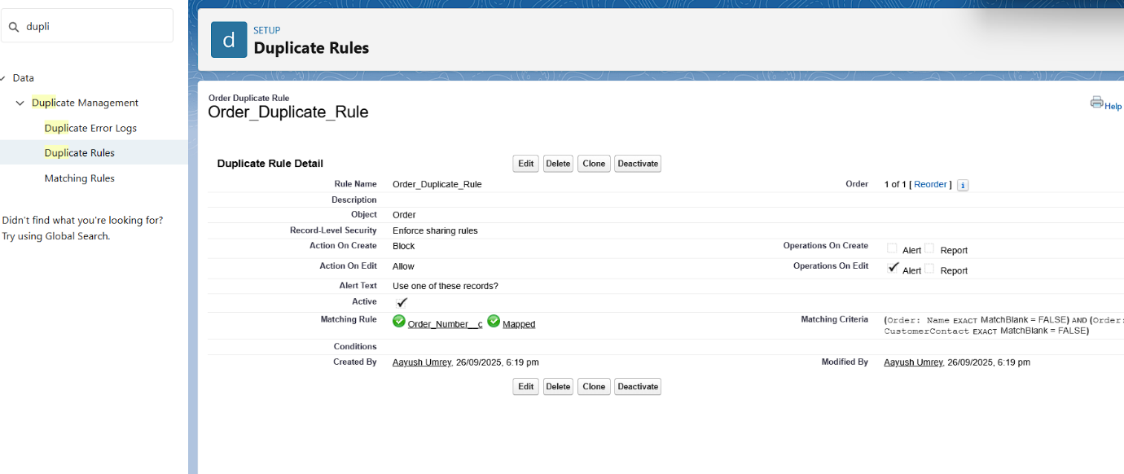

**Data Export & Backup:**

**What it is:** A Salesforce feature to export data from objects into CSV files, scheduled or manual.  
 **Used for**: Creating regular data backups for disaster recovery and compliance.

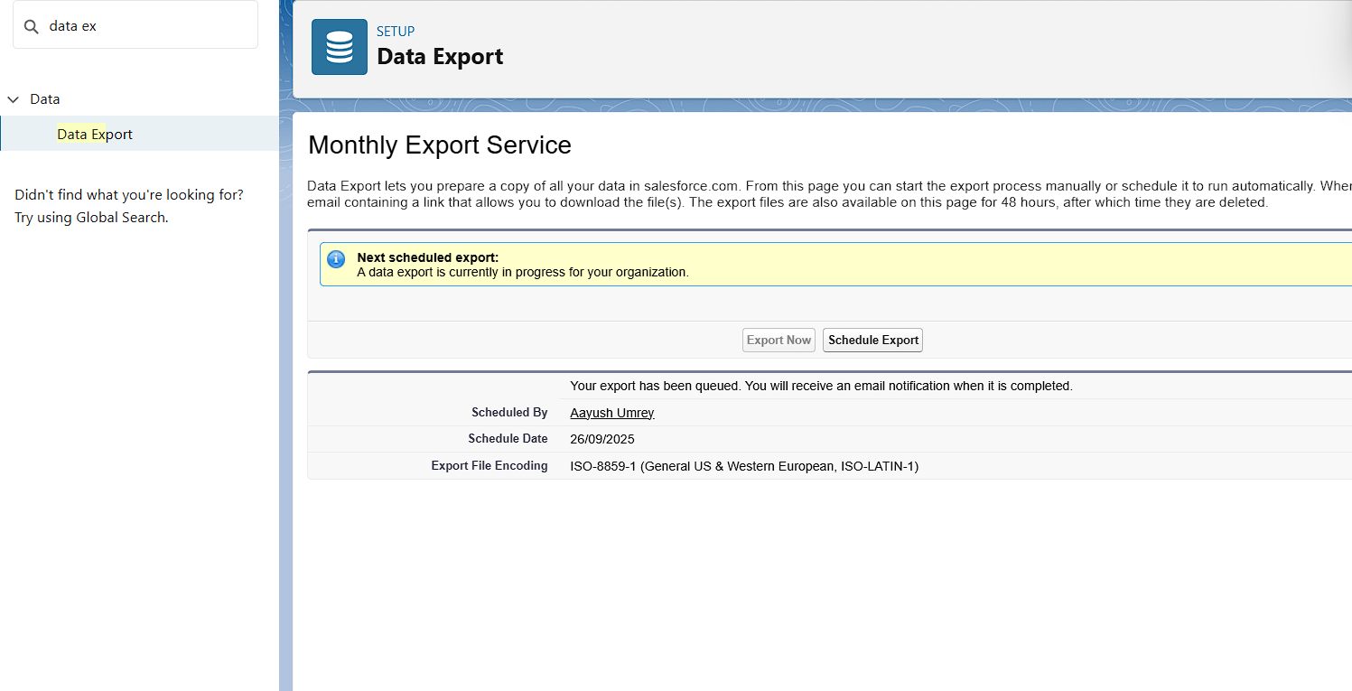

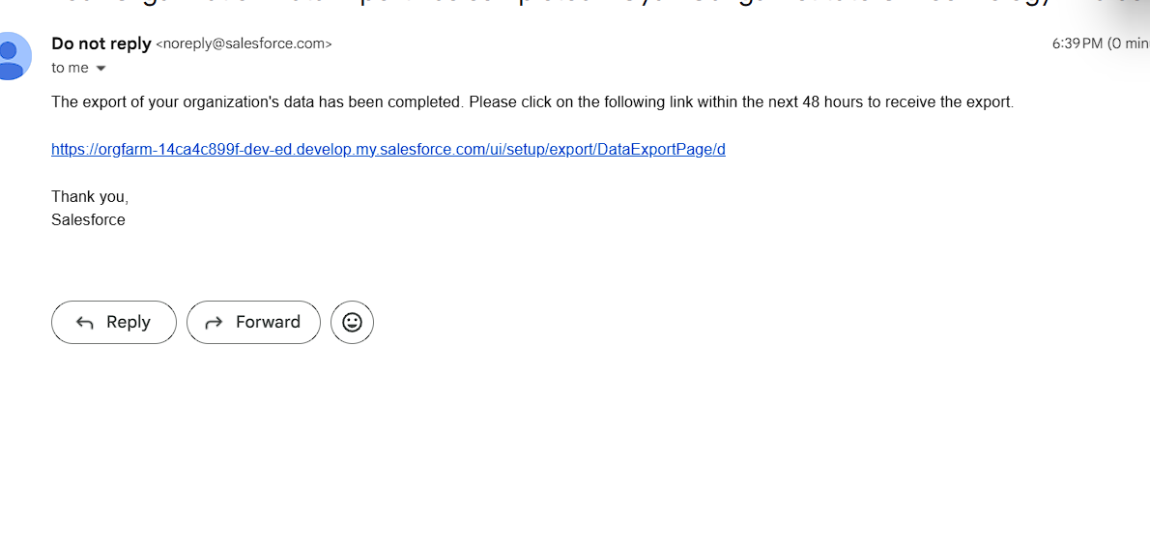**Change Sets:**

**What it is:** A point-and-click tool to move metadata between related Salesforce orgs (e.g., from sandbox to production).  
 **Used for:** Deploying configuration changes without using code.  
 **What I created:** Not available in developer org

**Unmanaged vs Managed Packages:**

**What it is:** Bundles of components for deployment.

**Unmanaged**: One-time bundles; code is editable in target org.

**Managed**: Versioned packages for distribution; supports upgrades and AppExchange.

**Used for:** Sharing metadata, distributing apps, or moving components between orgs.

**What I created:** An Unmanaged Package containing custom objects

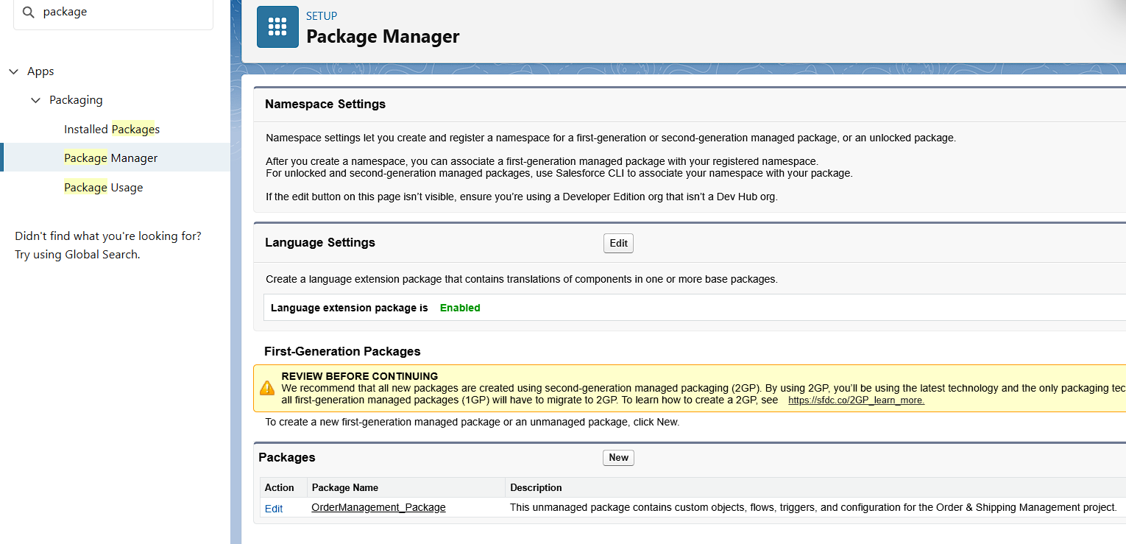

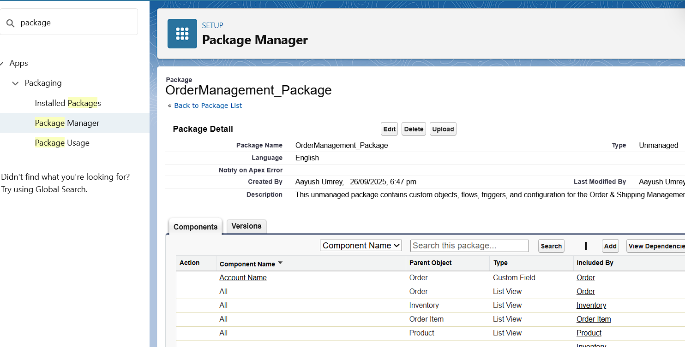

**ANT Migration Tool:**

**What it is:** A command-line tool (Java + Ant) for retrieving and deploying metadata using Salesforce Metadata API.  
 **Used for:** Automated deployments, scripting, and CI/CD pipelines.  
 **What I created:** Configured a simple package.xml to retrieve Apex Classes and deploy them to another Developer Org.

**VS Code & SFDX:**

**What it is:** A modern development environment using Salesforce CLI and extensions in Visual Studio Code.  
 **Used for:** Source-driven development, metadata retrieval/deployment, Apex testing, and CI/CD.

**What I created:** A Salesforce DX project in VS Code, connected to Developer Org, and deployed LWCs and Apex classes.

